SOFTWARE ENGINEERING MINI-PROJECT
Software Requirements Specification (SRS)
Real-Time Chat Application Using Socket Programming
Deliverable 1 – IEEE-Style SRS

Document Control
Item | Details
Document | Software Requirements Specification
Project | Real-Time Chat Application Using Socket Programming
Version | 1.0

1. Introduction

1.1 Purpose
This document specifies the requirements for a real-time chat application that enables multiple users to communicate through persistent socket/WebSocket connections. It provides a baseline for development, testing, validation, and design.

1.2 Scope
The system provides user registration and authentication, connection to a chat server, real-time text messaging, online-user visibility, connection/disconnection handling, and basic administrative user management.

1.3 Definitions and Acronyms
Term | Meaning
SRS | Software Requirements Specification
FR | Functional Requirement
NFR | Non-Functional Requirement
WebSocket | Persistent bidirectional client-server communication protocol
Client | User-side chat application
Server | Component managing connections and message routing

2. Overall Description

2.1 Product Perspective
The application follows a client-server model. Clients establish socket/WebSocket connections with the server. The server authenticates users, maintains active connections, and routes messages.

2.2 Product Functions
- Registration and authentication
- Socket connection management
- Joining and leaving chat
- Real-time text messaging
- Online-user display
- Disconnection/error handling
- Basic user administration

2.3 User Classes
Chat User – registers/logs in, joins the service, exchanges messages, views connected users, and logs out.
Administrator – performs basic user-management operations.

2.4 Operating Environment
The application may use Node.js with WebSockets or Python with Flask-SocketIO. Clients require network connectivity to the server.

2.5 Constraints
- Network connectivity is required.
- The implementation depends on the selected technology stack.
- The initial version focuses on text communication.
- Security controls must match the implemented architecture.

2.6 Assumptions and Dependencies
- The server is available when users connect.
- Users provide valid registration/authentication data.
- Required runtime dependencies are installed.
- Client and server can communicate over the configured network.

3. Specific Requirements

3.1 Functional Requirements
ID | Requirement
FR-01 | The system shall allow a new user to register using required account information.
FR-02 | The system shall authenticate a registered user using valid credentials.
FR-03 | The system shall reject invalid authentication attempts.
FR-04 | The system shall allow an authenticated user to log out.
FR-05 | The system shall establish a persistent socket/WebSocket connection between client and server.
FR-06 | The system shall allow an authenticated user to join the chat service.
FR-07 | The system shall allow a connected user to send a text message.
FR-08 | The system shall deliver a valid message to its intended recipient(s).
FR-09 | The system shall display received messages to the appropriate user(s).
FR-10 | The system shall associate a timestamp with each displayed message.
FR-11 | The system shall display messages in chronological order.
FR-12 | The system shall support simultaneous connections from multiple users.
FR-13 | The system shall maintain active-user connection status.
FR-14 | The system shall indicate when a user joins the chat.
FR-15 | The system shall indicate when a user disconnects.
FR-16 | The system shall display currently connected users.
FR-17 | The system shall validate message input before transmission.
FR-18 | The system shall reject empty or invalid messages.
FR-19 | The server shall route valid messages to appropriate recipient(s).
FR-20 | The system shall notify a user when the server connection fails or is terminated unexpectedly.

3.2 Non-Functional Requirements
ID | Attribute | Requirement
NFR-01 | Performance | Under normal expected load, a valid message should be delivered within 1 second.
NFR-02 | Concurrency | The system should support multiple simultaneous connections without unnecessary termination of active sessions.
NFR-03 | Availability | The service should remain available while the server is operational and handle client disconnections gracefully.
NFR-04 | Reliability | During a stable connection, each valid message should be delivered once to its intended recipient(s).
NFR-05 | Usability | A first-time user should be able to connect, authenticate, send a message, and log out without technical training.
NFR-06 | Maintainability | Client and server functions should be organized into modular components.
NFR-07 | Portability | The application should run in the supported environment with required dependencies.
NFR-08 | Scalability | The design should permit increased concurrent users without redesigning the basic communication mechanism.
NFR-09 | Input Validation | User-provided data shall be validated before processing or transmission.
NFR-10 | Response Time | Normal user actions should receive an observable response within 1 second under normal expected load.

4. External Interface Requirements

4.1 User Interface
- Registration/login and logout controls.
- Message composition and send control.
- Display of messages and timestamps.
- Connection status and connected-user list.

4.2 Communication Interface
Client and server shall communicate using the selected socket/WebSocket mechanism over the configured network connection.

5. Security Requirements

5.1 Security Objectives
- Ensure that only authenticated users can access protected chat functionality.
- Protect the integrity of chat operations through input validation and access control.

5.2 Security Requirements
ID | Requirement
SEC-01 | The system shall require authentication before granting access to protected chat functions.
SEC-02 | The system shall validate and sanitize user-provided registration, authentication, and message input.
SEC-03 | The system shall prevent unauthenticated clients from accessing protected chat messaging.
SEC-04 | The server shall verify authorization before executing administrative operations.

6. UML Use Case Diagram
The diagram identifies the primary actors and their interactions with the chat application.
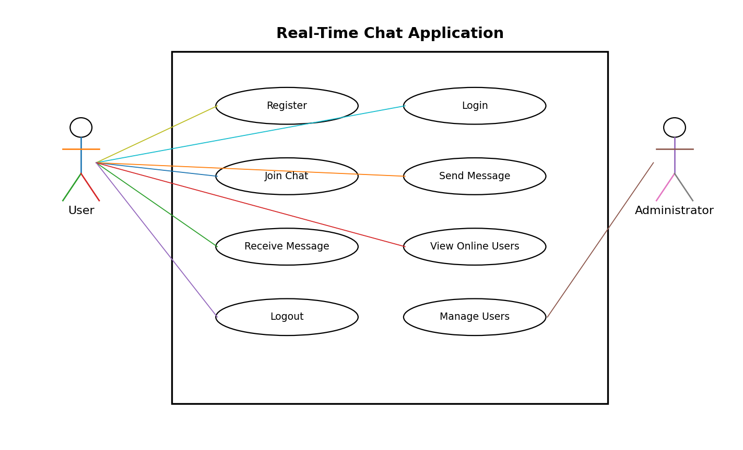

7. Requirement Quality and Traceability
Requirements are expressed as clear, concise, unambiguous, measurable, and testable 'shall' statements where applicable. Requirement IDs provide stable references for the Test Plan and the Requirements Traceability Matrix.

